*Florida International University*

*School of Computing and Information Sciences*

Software Engineering Focus

Feature Document

User Story #**900**

**Team Member:**

Daylin Gonzalez Miguel

**Product Owner(s)**:

Eddy Garcia

**Mentor(s)**:

NA

**Instructor**: Masoud Sadjadi

**User Story** Add optional information message to registration page

* As a developer, I have to add a message to the registration page so the user knows what information is optional

Acceptance Criteria

* Registration page shows a message in the optional information part

**Use Case** #**900 –** Add optional information message to registration page

|  |  |
| --- | --- |
| **Name** | **Optional information message** |
| **Brief Description** | **The optional info message use case allows the User to decide if he wants to add more info to his profile when creating an account.** |
| **Actor(s)** | **Guest** |
| **Flow of Events** | |
| **Basic Flow** | |
| **This use case starts when the User accesses the system feature that enables him/her to create an account.**  **1. The User creates an account entering email and password**  **2. The system displays a page for the user to enter required information**  **3. The user enters the information**  **4. The system displays a page for the user to enter additional information with a message that says that that information is not required but may be useful.**  ***5.* The use case ends** | |
| **Alternate Flows** | |
| **Title** | **Description** |
| **User Enters Additional Information** | **During Create Account, the user decides to enter additional information, the following occurs:**  **1. The user enters the information.**  **2. If valid information is entered, the system saves the information.**  **3. The user press Submit**  **4. Account created confirmation page shows up.** |
| **User does not Enter Additional Information** | **During Create Account, the user decides not to enter additional information, the following occurs:**  **1. The user press submit.**  **2. Account created confirmation page shows up.** |
| **Pre-Conditions** | |
| **Title** | **Description** |
| **User created account** | **The User created an account by entering a valid email and password.**  **The user entered required information** |
| **Post-Conditions** | |
| **Title** | **Description** |
| **Success** | **The User entered additional information and it is saved in the user’s account.** |
|  |  |
| **Extension Points** | |
| **None** | |

**Use Case Diagram**

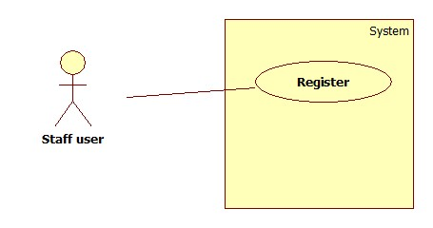

**Sequence Diagram**

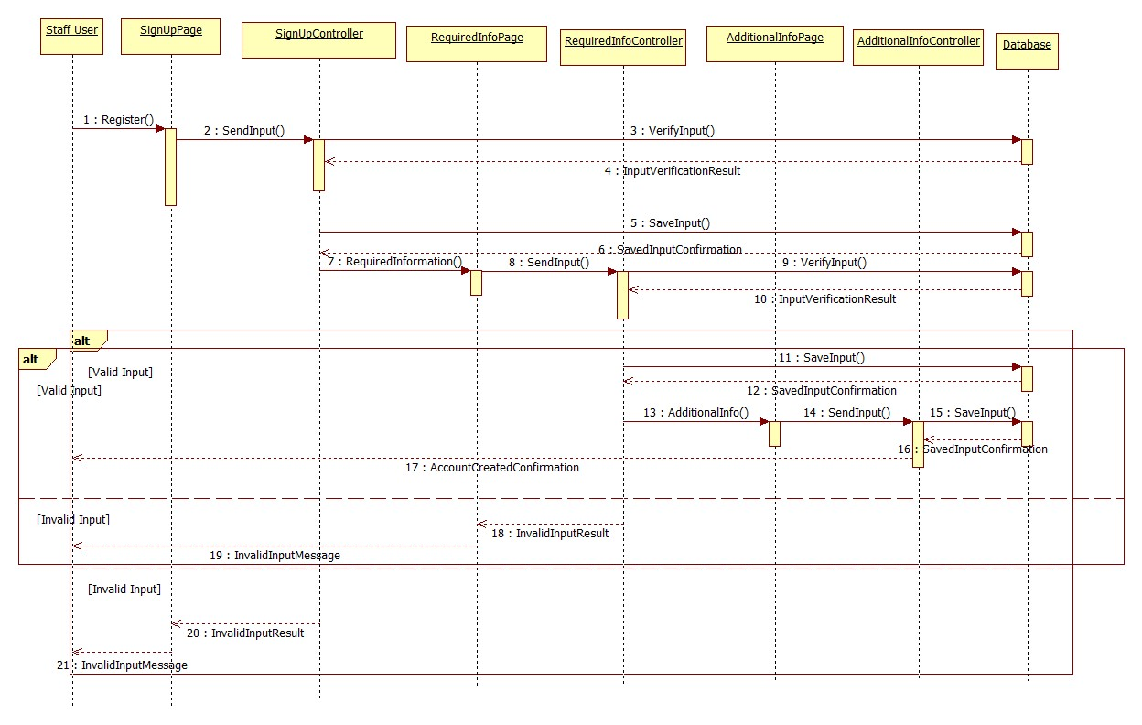

**Class Diagram**

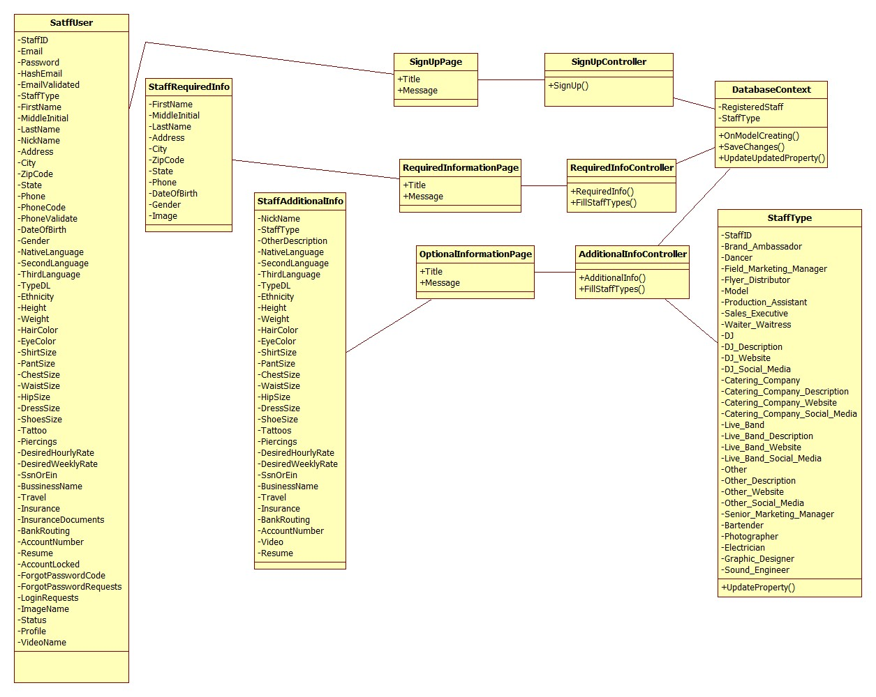

**Unit Test**

**Integration Test**

|  |
| --- |
| **Test ID: IT-004** |
| **Purpose: Verify whether the user is able to see the optional information message** |
| **Preconditions: Internet browser is open and application is running** |
| **Input: { Email = daylin25125@yahoo.es, FirstName = "Daylin", MiddleInitial = “M”, LastName = "Gonzalez", Address = “40 Sidonia Ave”, City = “Coral Gables”, ZipCode = “33134”, State = “FL”, Phone = “7865518745”, DateOfBirth = “12/15/85”, Gender = “Female”, Picture = “pic.jpg” }** |
| **Expected Output: The system displays the additional information page with a message on top informing the user that the information is not required but may increase the chances to get get a job.** |

**Visual User Guide**

